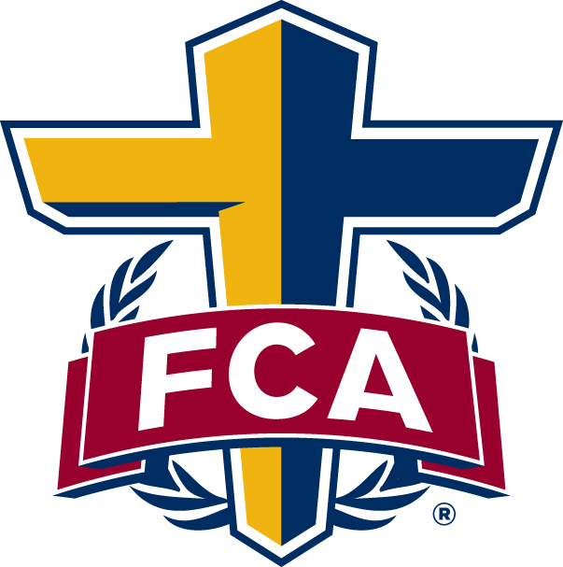

NEWS RELEASE
FOR IMMEDIATE RELEASE (DATE)

(Name of City/School) Students to Host FCA Fields of Faith Event, Joining Thousands of Youth Across U.S. on Oct. 14

(CITY, STATE)—Students from (name of city and/or local schools) will join thousands of other youth on athletic fields across the nation on Wednesday, October 14, 2020, to share their Christian faith with fellow students during the 17th annual national Fellowship of Christian Athletes’ (FCA, www.fca.org) Fields of Faith event. This rapidly growing, interdenominational outreach event will be held at more than 500 locations throughout the nation.

While many Christian rallies are anchored to an entertainer or professional speaker, FCA’s Fields of Faith is structured as a student-to-student ministry. Peers invite their own classmates and teammates to meet on their school’s athletic field to hear fellow students share their testimonies, challenge them to read the Bible and to come to faith in Jesus Christ.

(Optional quote from local FCA director or regional VP of Field Ministry)

This will be the (insert ordinal number, i.e. first, second) Fields of Faith event for (name of city and/or local schools). Last year, approximately (number of attendees) students and supporters attended at (insert location of event).

Fields of Faith began with an idea from Jeff Martin, FCA’s Executive Director of Ministry Advancement, who longed to help today’s generation of students face spiritual battles and temptations.

“It’s amazing that Fields of Faith has grown to welcome nearly a quarter of a million people to athletic fields where they can pray and worship together,” Martin said. “We are so thankful for the students who feel passionate about sharing their faith with their fellow students so they, too, can see how Christ can impact their lives. There’s no doubt that God is working through these young people and will continue to do so for years to come.”

In 2004, Martin’s vision became reality when 6,000 students gathered on school athletic fields throughout three states for the first Fields of Faith event. That was the beginning of what has become one of the most significant faith-related gathering of students in a single day.

While Fields of Faith has its roots with FCA leadership, the event is designed to include multiple national Christian organizations, local churches and ministries. A local leadership team will determine the program of each Fields of Faith event.

More information about the 2020 Fields of Faith event is available at FieldsofFaith.com. To learn more about the event in (name of city/school), contact (name of person and phone number and/or email address).

# # #

MEDIA CONTACT
(name of local contact)
(title)
(phone number)
(email address)

SUGGESTED SOCIAL MEDIA POST:
Join students from (name of school/city) for the 17th annual FCA Fields of Faith event at (location) Wednesday, Oct. 14! Learn more at www.fieldsoffaith.com.

