OCTOBER 9, 2019

YOUR FIELD NAME
1234 Custom Address City, State Zip Code • 5:00 PM

OCTOBER 9, 2019

YOUR FIELD NAME
1234 Custom Address City, State Zip Code • 5:00 PM

OCTOBER 9, 2019

YOUR FIELD NAME
1234 Custom Address City, State Zip Code • 5:00 PM

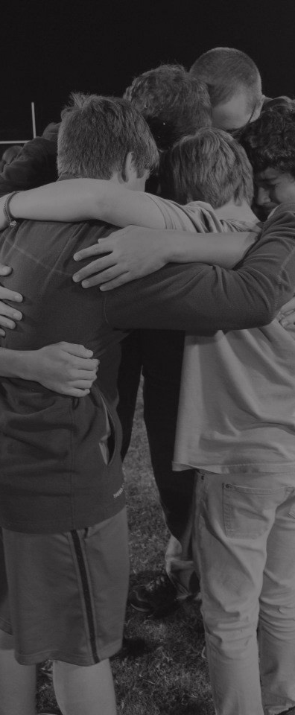

OCTOBER 9, 2019

YOUR FIELD NAME
1234 Custom Address City, State Zip Code • 5:00 PM

GET IN THE GAME
Fields of Faith is held on the second Wednesday in October when athletes stand together on their school’s athletic field to share their faith with their peers and community.

GET IN THE BOOK
The power of Fields of Faith is students impacting students. Fields of Faith provides student athlete leaders a platform to challenge their peers to read the Bible and follow Jesus Christ.

GET STARTED
Visit fieldsoffaith.com to find a field near you, or get key resources to host a field.

LOCAL CONTACT
Firstname Lastname 555.555.5555
email@email.com website

FieldsofFaith.com FieldsofFaith
@FieldsofFaith #FOF19

Fields of Faith is a program of the Fellowship of Christian Athletes © 2019

