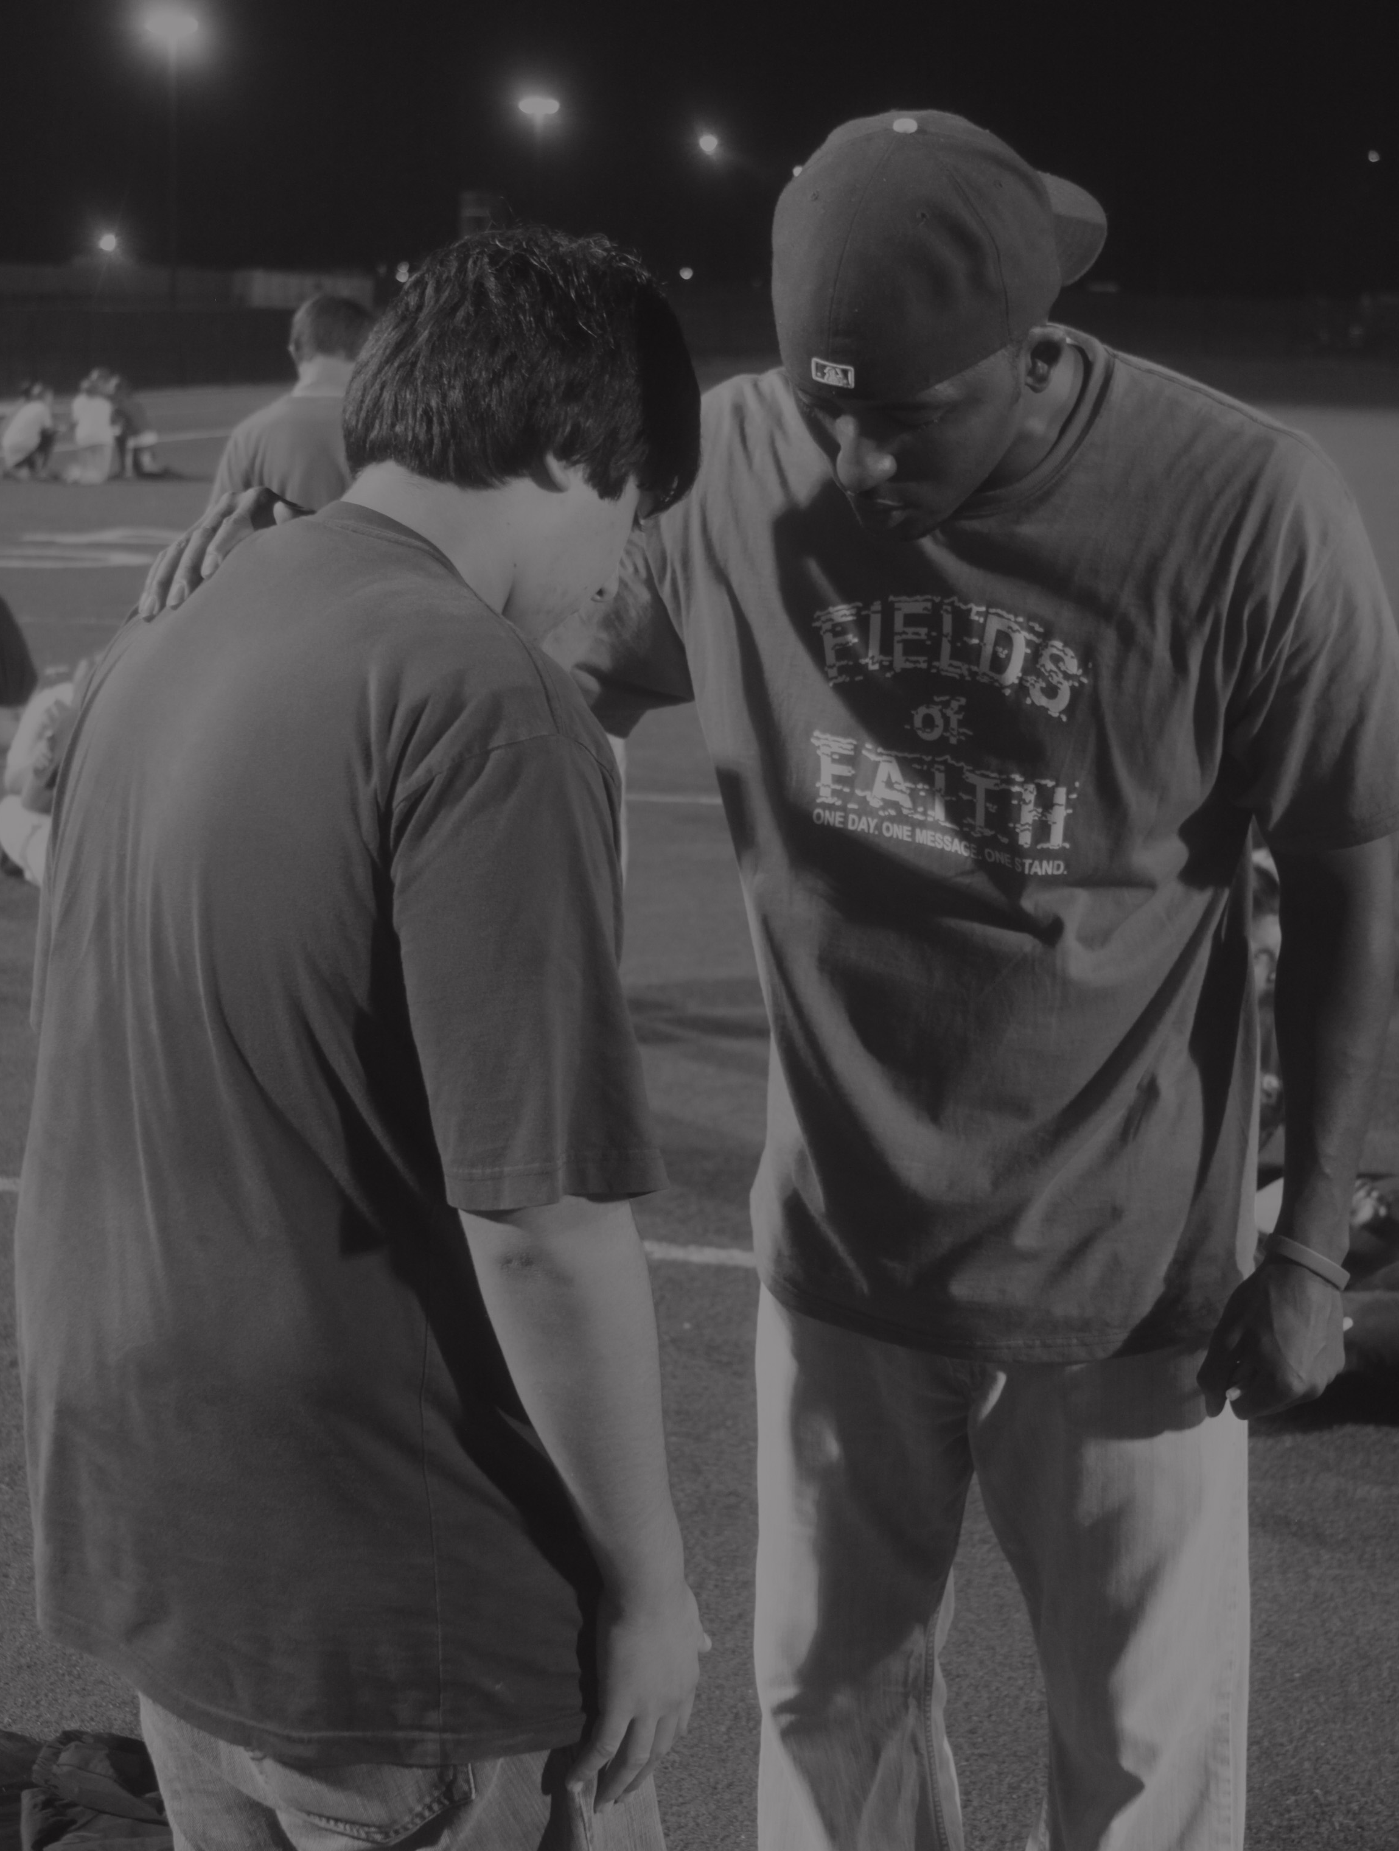

OCTOBER 9, 2019

YOUR FIELD NAME
1234 Custom Address City, State Zip Code • 5:00 PM

ONE DAY. ONE MESSAGE. ONE STAND.
Fields of Faith is a peer-to-peer movement where thousands of students from across the nation and world gather on their school’s athletic field to share stories and challenge each other to apply the Bible as their “game plan for life.”

FIELDSOFFAITH.COM

